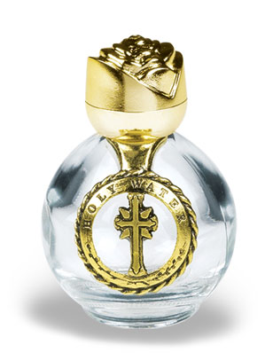

Please Don’t Drink the Holy Water
(and other information about what to do with a bottle of it)

Where did the holy water come from?
Your bottle of water was filled from the baptismal font here at St. Max. This water was blessed on Holy Saturday just before last Easter and again at every baptism.

Why do we use holy water?
Holy water is used for blessings for three reasons:
  - As a sign of repentance of sin,
  - For protection from evil,
  - As a reminder of our Baptism.
Each time we enter church and make the Sign of the Cross with holy water, we are reminded of our baptismal promises of rejecting Satan, all his works, and all his empty promises, and professing our faith.

How do I use it?
You can use it to bless yourself, to bless someone and to bless an object. Most Catholics pray ‘In the Name of the Father, and of the Son, and of the Holy Spirit, Amen.” When performing a blessing with holy water. Common objects to bless and sprinkle with holy water are rooms in a home, computers, cars, etc. Parents often bless their children by wetting their thumb with holy water and making a Sign of the Cross on their child’s forehead. Another beautiful prayer to say when blessing with holy water is ‘By thy Precious Blood and by this holy water, cleanse me/him/her from my/their sins, O Lord.”

Can I get more?
Sure! Reuse the bottle as often as you’d like by refilling it at our baptismal font.

How do I dispose of holy water?
Holy water is usually made with a touch of salt which is a preservative, but if your holy water were to go a little, um, green, the proper way to dispose of it is the same as for any sacramental; you want to return it to the earth. You should dig a small hole and pour it into the earth.

Read more about holy water at http://www.fisheaters.com/water.html and http://www.catholic.com and search for holy water.

